**Experiment 6:**

**Aim:** To write a python program to implement a vaccum cleaner program.

**Algorithm:**

1. Represent the environment as a grid or list with rooms marked as clean (0) or dirty (1) and define the vacuum's initial position.
2. Actions: Suck to clean the current room, and Move to adjacent rooms (left, right, up, down if grid-based).
3. Goal: Ensure all rooms are clean.
4. Control Logic: Use a reflex agent to clean dirty rooms and move to the next, avoiding revisiting cleaned rooms.
5. Display: Show the sequence of actions and the final cleaned state of the environment.

**Program:**

def vacuum_cleaner():

"""

Simulate a simple vacuum cleaner reflex agent in a two-room environment.

"""

# Input the initial states of rooms

room_A = input("Enter the state of Room A (Clean/Dirty): ").strip().lower()

room_B = input("Enter the state of Room B (Clean/Dirty): ").strip().lower()

# Input the initial location of the vacuum cleaner

vacuum_location = input("Enter the vacuum cleaner's starting location (A/B): ").strip().upper()

# Validate inputs

if room_A not in ["clean", "dirty"] or room_B not in ["clean", "dirty"]:

print("Invalid input! Room states must be 'Clean' or 'Dirty'.")

return

if vacuum_location not in ["A", "B"]:

print("Invalid input! Vacuum location must be 'A' or 'B'.")

return

# Initialize steps and cost

steps = []

cost = 0

# Perform cleaning based on the reflex agent rules

if vacuum_location == "A":

if room_A == "dirty":

steps.append("Clean Room A")

room_A = "clean"

cost += 1

if room_B == "dirty":

steps.append("Move to Room B")

cost += 1

steps.append("Clean Room B")

cost += 1

room_B = "clean"

elif vacuum_location == "B":

if room_B == "dirty":

steps.append("Clean Room B")

room_B = "clean"

cost += 1

if room_A == "dirty":

steps.append("Move to Room A")

cost += 1

steps.append("Clean Room A")

cost += 1

room_A = "clean"

# Output results

print("\nActions taken by the vacuum cleaner:")

for step in steps:

print("- " + step)

print("\nFinal room states:")

print(f"Room A: {room_A.capitalize()}")

print(f"Room B: {room_B.capitalize()}")

print(f"\nTotal cost: {cost}")

if __name__ == "__main__":

print("Vacuum Cleaner Problem")

vacuum_cleaner()

**Output:**

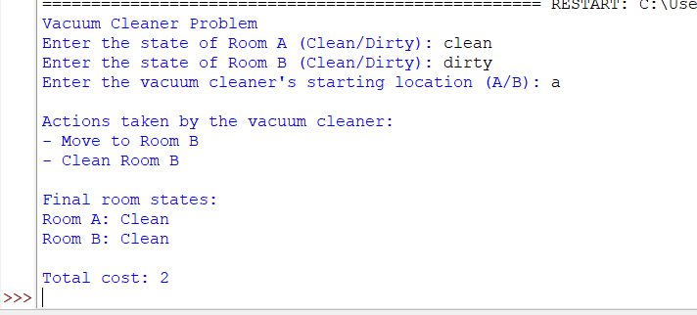

**Result:** Thus, the program was successfully completed using python programming.